**C Programming and Data Structures**

**Computer Science and Technology-B**

**Week 14**

14. a)Write a C program to implement all string operations (string length, string copy, string compare, string concatenation and string reverse) without using standard string library functions.

**Simple Program**

#include<stdio.h>

#include<string.h>

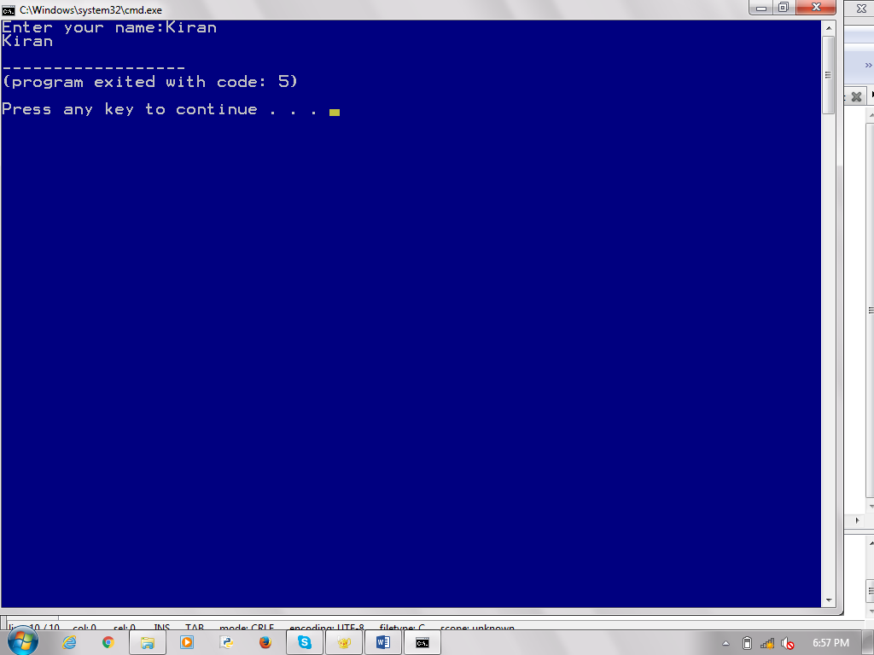void main()

{

char name[10];

printf("Enter your name:");

scanf("%s",&name);

printf("%s",name);

}

**Simple Program 2**

#include<stdio.h>

#include<string.h>

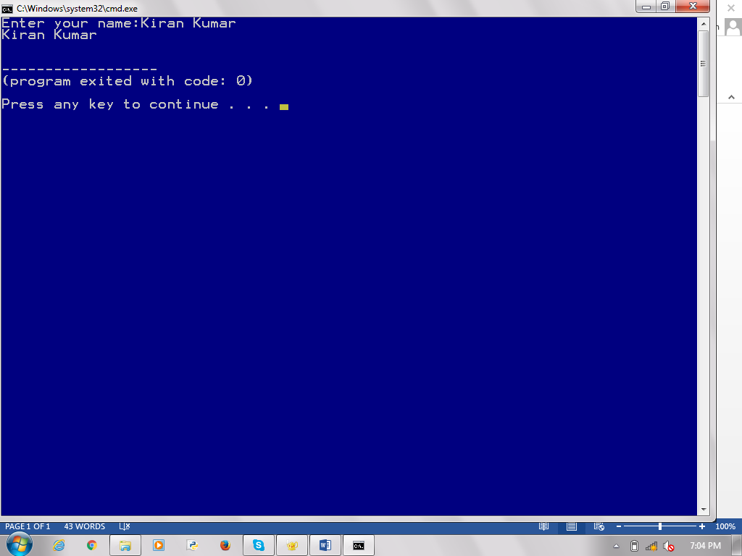

void main()

{

char name[10];

printf("Enter your name:");

gets(name);

puts(name);

}

**STRING FUNCTIONS**

**strcat()-** Concatenates str2 at the end of

str1

#include<stdio.h>

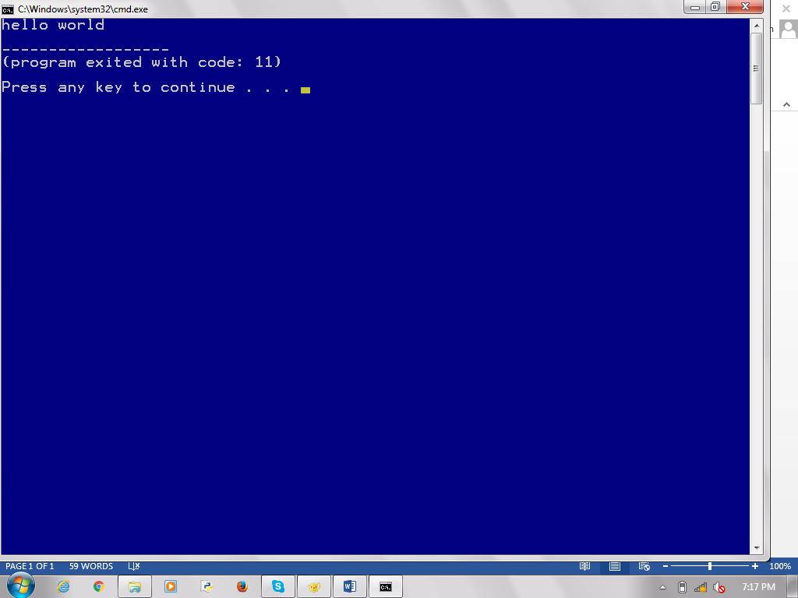#include<string.h>

void main()

{

char a[]="hello ";

char b[]="world";

strcat(a,b);

printf("%s",a);

}

**strncat()-** Appends a portion of string to another

#include<stdio.h>

#include<string.h>

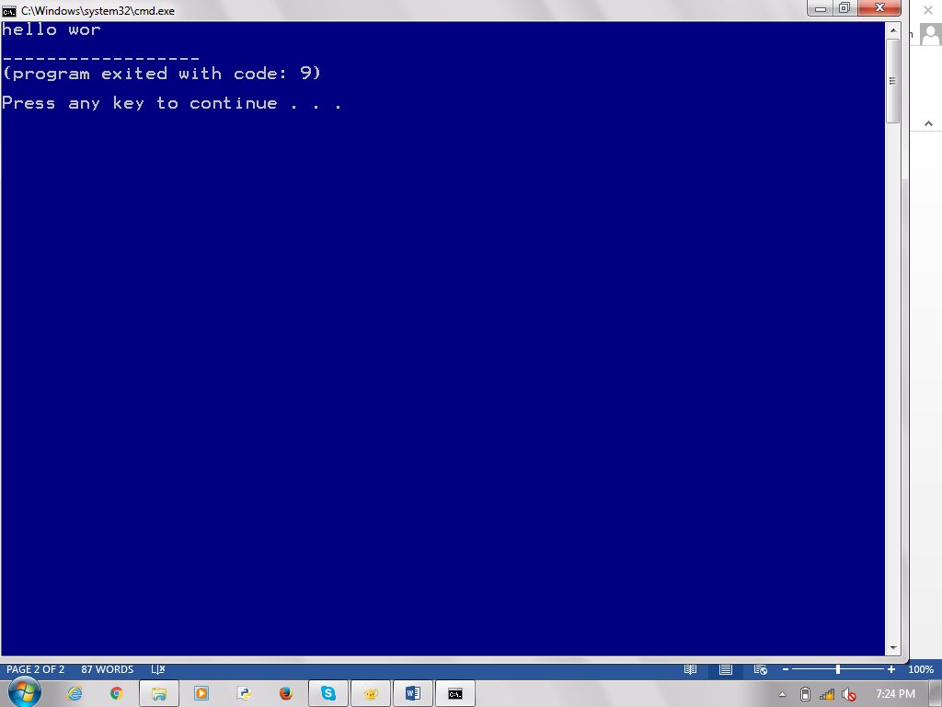void main()

{

char a[]="hello ";

char b[]="world";

strncat(a,b,3);

printf("%s",a);

}

**strcpy()-** Copies str2 into str1

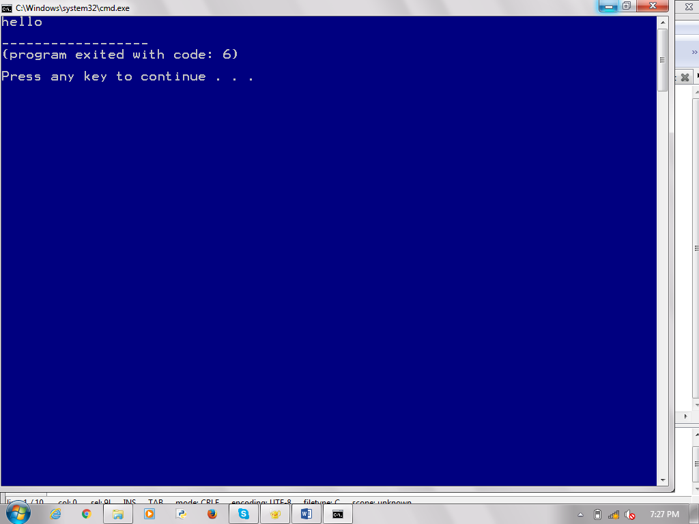#include<stdio.h>

#include<string.h>

void main()

{

char a[]="hello ";

char b[]="world";

strcpy(b,a);

printf("%s",b);

}

**strncpy()-** Copies given number of characters of

one string to another

#include<stdio.h>

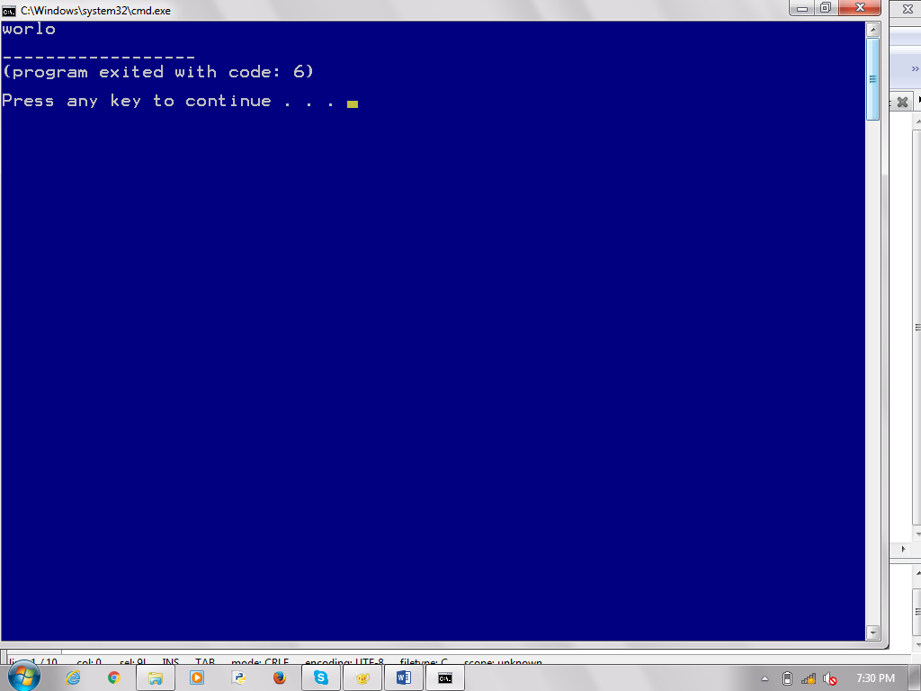#include<string.h>

void main()

{

char a[]="hello ";

char b[]="world";

strncpy(a,b,3);

printf("%s",a);

}

**strlen()-** Gives the length of string

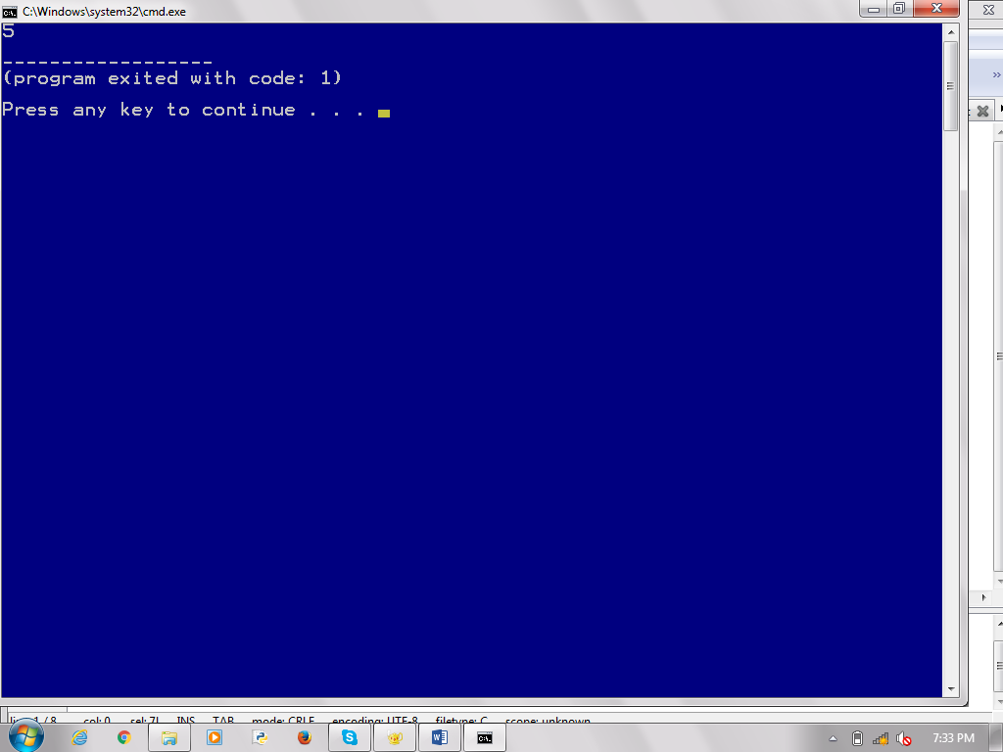#include<stdio.h>

#include<string.h>

void main()

{

char b[]="world";

printf("%d",strlen(b));

}

**strcmp()-** Returns 0 if str1 is same as str2.Returns <0 if strl<str2. Returns >0 if str1>sts2

#include<stdio.h>

#include<string.h>

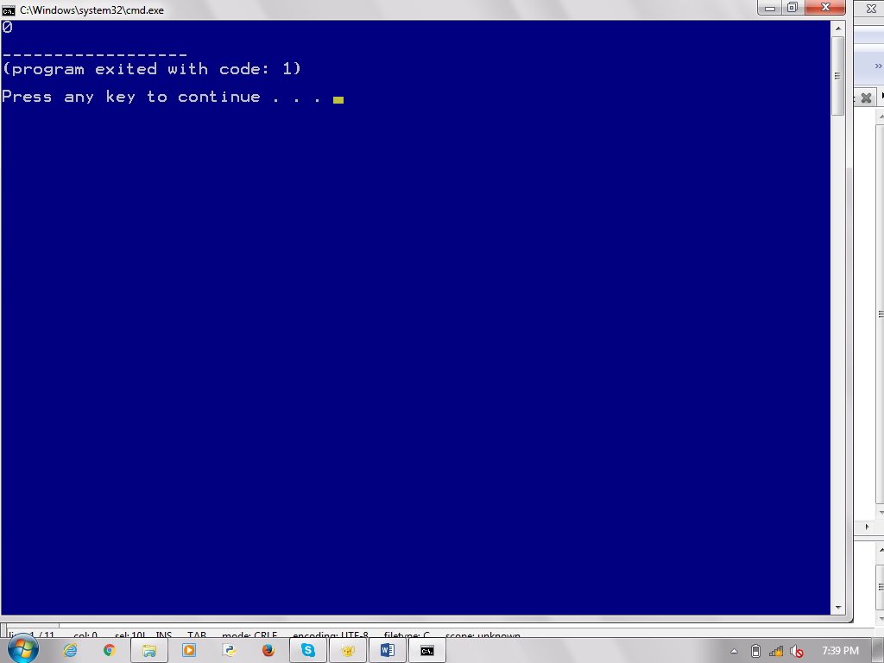void main()

{

int c;

char a[]="hello";

char b[]="hello";

c=strcmp(a,b);

printf("%d",c);

}

**strcmpi()-** Same as strcmp() function. But, this function negotiates case. “A” and “a” are treated as same.

#include<stdio.h>

#include<string.h>

void main()

{

 int c;

char a[]="Hello";

char b[]="hello";

c=strcmpi(a,b);

printf("%d",c);

}

**strlwr()-** Converts string to lowercase

#include<stdio.h>

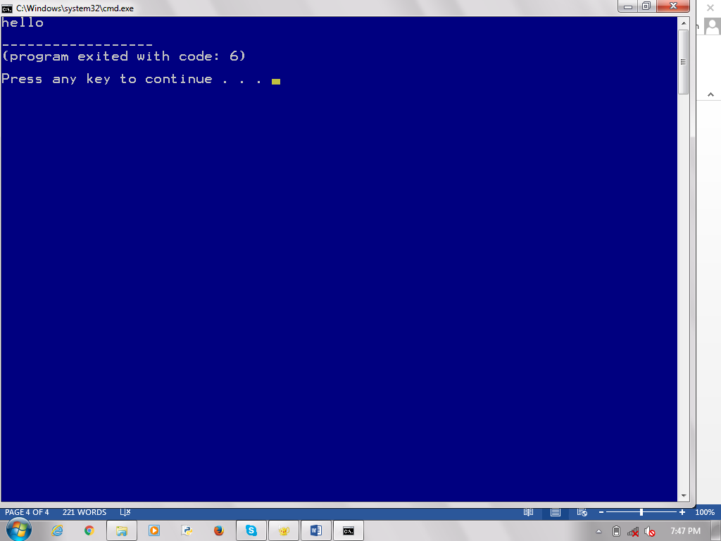#include<string.h>

void main()

{

char a[]="HELLO ";

printf("%s",strlwr(a));

}

**strupr()-** Converts string to uppercase

#include<stdio.h>

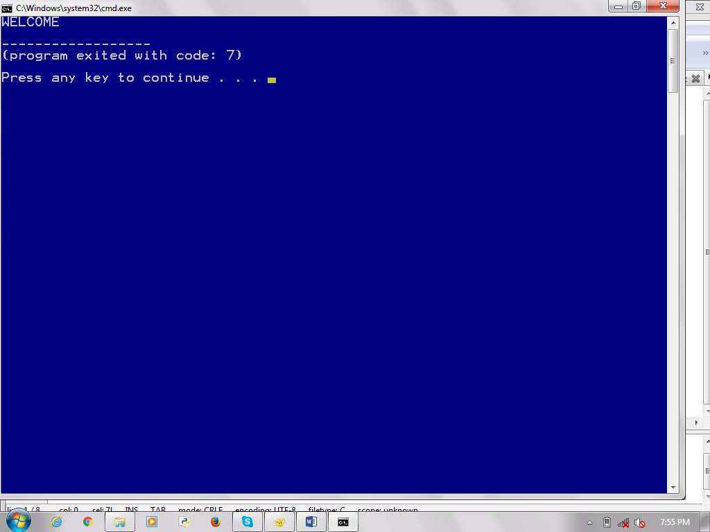#include<string.h>

void main()

{

char a[]="welcome";

printf("%s",strupr(a));

}

**strrev()-** Reverses the given string

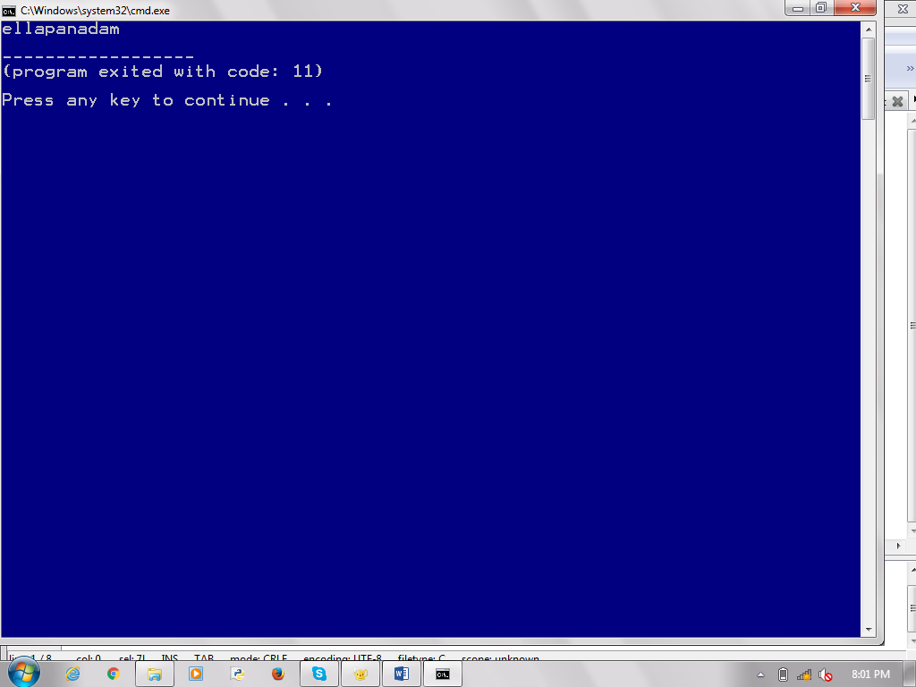#include<stdio.h>

#include<string.h>

void main()

{

char a[]="madanapalle";

printf("%s",strrev(a));

}

b) Write a C program for reading a string and assigning its base address to the character pointer to count characters are vowels or consonants.

**Program:**

#include<stdio.h>

#include<string.h>

int main()

{

char str[100];

char *ptr;

int vowel=0,cons=0;

printf("Enter a String:");

gets(str);

ptr=str;

while(*ptr!='\0')

{

if(*ptr=='A'||*ptr=='E'||*ptr=='I'||*ptr=='O'||*ptr=='U'||*ptr=='a'||*ptr=='e'||*ptr=='i'||*ptr=='o'||*ptr=='u')

{

vowel++;

}

else

{

cons++;

}

ptr++;

}

printf("Vowels:%d\n",vowel);

printf("Consonents:%d",cons);

}

**Output:**

